Pokhara University

Level: Bachelor | Semester – Spring | Year : 2006
Programme: BE |  | Full Marks: 100
Course: Engineering Economics |  | Time : 3hrs.

Candidates are required to give their answers in their own words as far as practicable.
The figures in the margin indicate full marks.

Attempt all the questions.

 | - What do you mean by law of demand and supply? Explain the factors influencing the demand.  - State and explain the law of diminishing marginal utility. |  |  |  |  | 8  7
 | - A bank gives a loan to a company to purchase an equipment worth Rs. 10,00,000 at an interest rate of 18 % compounded annually. This amount should be repaid in 15 yearly equal instalments. Find the instalment amount that the company has to pay to the bank.  - Solve for P₀ in the cash flow diagram shown below by using only two interest factors. The interest rate is 11% per year.  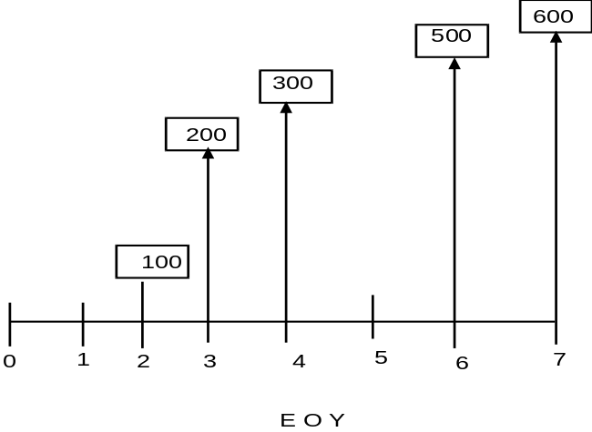  - If the nominal interest rate is 16.5%. Find effective interest rate Compound daily, monthly and quarterly. |  |  |  |  | 5  5  5
 | - An investment of Rs.10,000 can be made in a project that will produce uniform annual revenue of Rs.5,310 for five years and then have a market (salvage) value of Rs.2,000. The company is willing to accept any project that will earn 10% per year or more, on all invested capital. Show whether this is a desirable investment by using the Present worth and Annual worth method.  - Find the B/C ratio by both conventional and modified methods using AW formulation.  First investment = Rs. 1,00,000  Annual revenue = Rs. 40,000  Annual cost = Rs, 19,000  Salvage value =Rs. 20,000  MARR (interest) = Rs. 10%  Number of years = 10 |  |  |  |  | 7  8
 | - Which project is feasible? Use PW or FW using repeatability method |  |  |  |  | 8
 |  | Computer A |  | Computer B
 | Initial investment | Rs.3,50,000 |  | Rs.4,50,000
 | Annual revenue | Rs.1,50,000 |  | Rs.1,75,000
 | Annual Cost | Rs. 30,000 |  | Rs. 40,000
 | Salvage Value | Rs. 50,000 |  | Rs. 75,000
 | MARR | 15% |  | 15%
 | Life in years | 4 |  | 5
 | - What are terms used in a balance sheet? Explain with an example of a balance sheet. |  |  |  |  | 7
5. | - What do you mean by contingent, incontinent and mutually exclusive projects, describe with suitable example.  b) We are considering the purchase of second-hand computer at a cost of Rs. 16,000, with an estimated salvage value of zero and a projected useful life of five years. Interest is 10%.  Determine:  - Sum of Years Digits ( SOYD) depreciation  - Sinking depreciation  - Double Declining Balance with conversion to Straight Line depreciation |  |  |  |  | 5  10
6. | - Elaborate the differences between sole proprietorship, partnership, private limited company and public limited company.  - How many hours per year would the motor have to be operated at fall load, so that the annual cost to be equal? |  |  |  |  | 8  7
 | Item |  | Motor A |  | Motor B
 | Investment in Rs. |  | 1,20,000 |  | 1,50,000
 | Horse power |  | 100 |  | 105
 | Efficiency of motor |  | 74% |  | 90%
 | Life in years |  | 10 |  | 10
 | MARR |  | 15% |  | 15%
 | Maintenance cost/yr. Rs |  | 3200 |  | 2550
 | Tax is 1.5% of investment |  | …….. |  | ……..
 | Electricity cost |  | 5/Kwh |  | 5/Kwh
7. | Write short notes on (Any Two):  - Taxation in Nepal  - Nominal and effective interest rate  - Pay back period |  |  |  |  | 5×2

